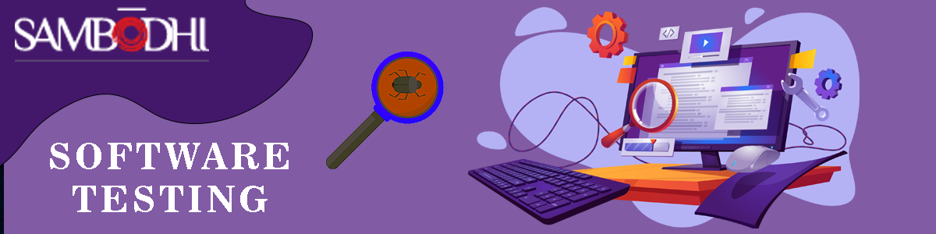

**Selenium Appium Training Course**

Project Based Immersive Learning Course

**Appium Training Course Overview**

Appium is an open source mobile application UI Testing framework. Education Nest offers a training program called "Mobile App Testing Using Appium," which is designed to teach you the core concepts of Mobile Test Automation. With Appium, you can test native, hybrid, and web applications, and you can perform automation testing on physical devices. Appium supports cross-platform application testing, which means that a single API can work for both Android and iOS platform test scripts. The training program covers topics such as the Appium Architecture, TestNG Framework, ADB, and UIAutomator. The course is designed to simplify each line and explain the concepts in an easy-to-understand manner, allowing you to become an expert in this area by the end of the course.

**Benefits of Appium Training Course:**

Enrolling in an Appium training program, you can develop proficiency in mobile automation testing, which can give you a competitive advantage in your career. Appium is one of the top tools used for mobile app testing, and the course is designed to teach you the core concepts of Mobile Test Automation. With the rise of mobile applications in major IT industries, there are numerous job opportunities available for Appium professionals around the world. The training course is 100% job-oriented. By completing the course, you can enhance your career prospects and take advantage of the growing demand for Appium professionals in the job market.

**Who should learn?**

* QA engineers
* System analysts
* Software testers
* Mobile app developers
* Technical managers
* Developers aspiring to be ‘Mobile Test Automation engineers'

**Why do you need Appium Training Course?**

**Average Salary Growth:**

The average salary growth of an Appium expert can vary depending on a number of factors, including location, industry, experience level, and specific job role. According to Indeed.com, a Mobile Test Automation Engineer makes an average salary of $109,521. Also according to Payscale, the average salary for a Software Test Automation Engineer with Appium skills is around $85,000 per year in the United States. As the level of experience increases, the salary can also increase significantly.

**Industries:**

The demand for Appium experts is high in various MNCs (multinational corporations) across different industries. This is because mobile app development has become increasingly important for businesses to reach their target audience and stay competitive in the market. Appium is a widely used mobile automation testing tool, and companies are looking for professionals who are skilled in this area to ensure the quality and reliability of their mobile applications. Some examples of these MNCs include Amazon, Google, Microsoft, Accenture, Cognizant, TCS, Infosys, and Wipro.

**Position in Market:**

According to the US Bureau of Labor Statistics (BLS), employment of software developers (which includes mobile app developers and automation testing engineers) is projected to grow 22% from 2019 to 2029, much faster than the average for all occupations. Moreover, a report by Grand View Research projects that the global mobile automation testing market size will reach $20.6 billion by 2027, with a compound annual growth rate (CAGR) of 15.7% from 2020 to 2027.

**Designations:**

* Mobile Test Automation Engineer
* Mobile Automation Tester
* QA Automation Engineer
* Software Test Engineer
* Automation Test Lead
* Test Manager
* Quality Assurance Analyst
* Mobile Application Developer with Automation Testing skills

**Why Appium Training Course from Education Nest**

* + - * **Free Demo on Request**
      * **Live Interactive Learning**
      * **Lifetime Access**
      * **Flexible Schedules**
      * **24x7 Support**
      * **One on One Doubt Clearing**
      * **Real Time Project-Based Learning**
      * **Certificate Oriented Curriculum**

**Key Skills Covered:**

* Why Mobile Testing?
* Different types of Mobile Platforms
* Challenges with Mobile Testing
* Different approaches to Mobile Testing
* Selenium automated testing
* How to use Appium?
* Utilizing Appium to automate the handling of key events and gestures
* Automating synchronization and application management processes
* Network management and performance testing using Appium
* Automating hybrid and native apps

**Appium Training Course Syllabus**

**Module1: (Introduction to Appium)**

* What is testing
* About Web Automation, UI automation, and mobile automation
* What is Appium and its Features
* Native, hybrid and web apps
* Appium Internal Architecture

**Module2: (Appium Setup & Installation)**

* Prerequisite
  + Tool installation
* How Appium Works
  + Appium Internal Architecture(explaining again)
* APK File
* Real Device vs Simulator vs Emulator Testing
* Creating Virtual Device
* How to inspect elements in Appium
* UI Automator

**Module3: (First Code in Appium)**

* Android App download for practice
* how to find App Activity and App Package
* Creating First Code(java project)
* What is Desired Capabilities? How to talk to appium server
* Invoking Android Driver-Creating base program

**Module4: (Touch Actions)**

* Difference between Android Driver, IOS Driver, Appium Driver and Remote WebDriver
  + Remote Driver
  + Appium and Android Driver
    - Trail code using Android or Appium Driver

**Module5: (Advanced Gestures)**

* Auto complete text box
  + Implicit wait
  + Actions
  + Press Key
* Long Press Events
  + Views/drag and drop
  + Touch Action Class
  + Views/drag and drop
  + Take screenshots
    - File Utilities
* Handling Alerts
  + Alert dialog
    - Repeat alarm
    - Text Entry Dialog
* Handling Switches
  + Views/Switches
* Web Automation

**Module6: (Advanced Gestures Testing Introduction)**

* App notifications
  + Incoming notifications
  + Validating notifications
  + Operations for operating objects
* TestNG
  + Testing Annotations
    - Before & After Test
    - Before & After Class
    - Before & after Suite

**Module7: (Log4j Introduction)**

* TestNG Demo
  + Test cases
    - First automation
    - Previous Releases
  + Testing XML(Updating Parameters in XML file)
* Log4j-Introduction
* Log4j-Methods
* Log4j-Appenders
* How to implement Logs

**Module8: (Log4j Maven)**

* What is Maven
* Pom.xml
* Maven life-cycle
* Sample example for Generating the Reports using Maven
* How to enable Log4j
* Example on Log4j

**Module9: (Framework Building)**

* What is Framework
  + Page object Model
* How to create a Framework
  + Building Framework in step by step process

**Career Support**

**Profile Building:**

Experienced professionals are available to offer tailored assistance in crafting your CV and online profiles, taking into account your unique educational and experiential background.

**Interview Preparation:**

The upcoming interview preparation service will include personalized one-on-one sessions and the option for mock interviews if needed.

**Job Referrals:**

At Education Nest, we receive a variety of job requirements from diverse sources such as organizations, our clients, HR consultants, and a vast network of Education Nest currently employed in different companies. We strive to meet these varied requirements to the best of our abilities.

**Continuous Support:**

We offer continuous support for as much time as you need it, and a considerable number of our learners receive multiple interviews offers and promising employment opportunities as a result of the abilities they gain during the program.